**Web Server**

* Server refers to a computer or software solution where we can host, process and handle requests.
* Web Server resembles both hardware and software.
* It satisfies the client request by sending and receiving data.
* Web Server is responsible for hosting your applications, process and handling requests in Web.
* Web Server is also known as Http Server.
* The popular web server software
  + Microsoft IIS [Internet Information Services Manager]
  + Apache Tomcat
  + Node.js
  + NGINX
  + Lighttpd etc.
* We are going to use the webserver locally our machine, web build application, test, and then we can deploy on live servers.

**Windows Web Server**

* Windows OS comes with a webserver called “Internet Information Services”
* **Locate the Web Server on your windows PC**.
  + Open windows control panel
  + Switch to “Large Icon” view
  + Go to “Administrative Tools”
  + Look for “Internet Information Services Manager”
* **Add web server to your windows PC if not available**
  + Go to Control Panel
  + Open “Programs and Features”
  + Click on “Turn Windows Features ON or OFF”
  + Select “Internet Information Services”
  + Click OK
* **Test Web Server**
  + Open any browser
  + Request the following URL  
    <http://localhost>

<http://127.0.0.1>

**Web Site**

* Web is virtual directory on Web Server.
* It provides access to the resources.
* Web [Portion of Internet]
* Site [Location – usually in computing system location is referring to drive and directory]
* **Create a new Website on your local server**
  + Open IIS [run – inetmgr]
  + Expand local computer [http://localhost]
  + Expand “Sites” folder
  + Right click on “Default Web Site”
  + Select the option “Add Virtual Directory”

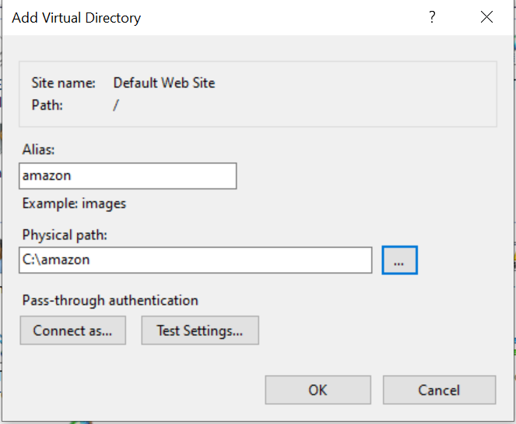

Alias: Web Site Name [http://localhost/amazon]

Physical Path: Resource Location [C:\amazon]

**Note: You have to use “\” backslash for physical path and “/” forward slash for virtual path. For URL always use forward slash.**

**Web Page**

* Web page provides a user interface (UI) from where user can interact with the resources in our application.
* Web page is a Hyper Text document that provides interface for interacting with resources.
* The term “**Hyper**” is derived from a *Greek term*, which means “**beyond**”.
* Hyper Text document is a document that contains information beyond what is displaying.
* The web pages are classified into 2 types
  + Static Page
  + Dynamic Page

**Static Page**

* Static refers to continuous memory.
* The memory allocated for first request will continue for others.
* Static page contains information that will be same across any number of requests.
* Static page responds with the same content across any number of requests.
* Static Pages will have extension
  + .htm
  + .html

**Dynamic Page**

* Dynamic refers to discreet memory.
* The memory is newly allocated for every request.
* Dynamic page contains information that is customized according to the client request.
* Dynamic pages have extension
  + .aspx
  + .asp
  + .php
  + .jsp

Note: Every website that you designed starts with a default page called “index.html”. We need a mark up language to design a web page. HTML